VOLLEYBALL STUDY GUIDE

SKILLS
Bump or forearm pass - Skill most often used to receive serves or passes when the ball is below the shoulders
- Ready position: Knees bent and hands connected.
- Contact: lock out elbows, meet the ball with the forearms
- Follow through: point the forearms toward the intended target and lift with the legs.

Set or overhead pass - Skill used to pass the ball above the height of the net so the ball can be spiked by teammate.
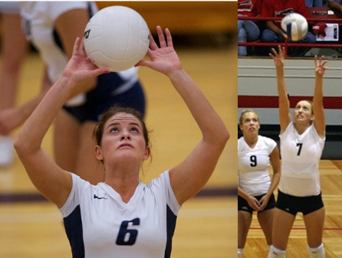
- Ready position: hands spread out above your head with elbows and knees bent.
- Contact: meet the ball with the finger pads spread out on the ball.
- Follow through: extend legs and arms, and push up with the wrist snapping out to the sides.

Serving - Skill used to put the ball in play to start the game and to begin play after each point.

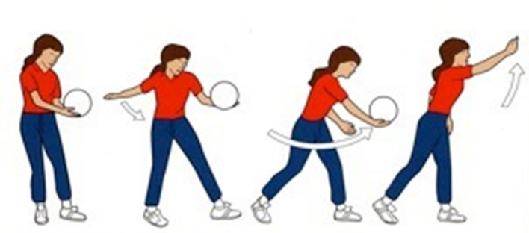
- Underhand: easier to perform (ball is hit from a stationary position) and easier to return (Lob).
- Ready position: Hold ball, waist high, in the non-dominate hand.
- Contact: Step in opposition and strike the ball out of your hand.
- Follow through: Step toward and swing the arm toward the intended target.

- Overhead: more difficult to perform (ball is tossed and moving when hit) and more difficult to return (driven downward with more force).
- Ready position: stand sideways to the target holding the ball in the non-dominate hand.
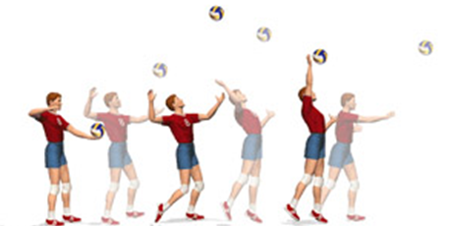
- Contact: toss the ball up and infront of your body, step in oppostion and rotate forward to meet the ball.
- Follow through: Strike the ball with the hand open toward the intended target.

GENERAL RULES
6 players on a team, 3 on the front row and 3 on the back row.
On each side of the net only a maximum of three hits are permitted.
A player may not hit the ball two times in a row. (A block is not considered a hit)
The ball may be played off the net during a volley and on a serve.
A serve that fails to go over the net is a fault and results in a point for the opponent.
A ball hitting a boundary line is “in”
The server must be behind the backcourt line and can’t step on the line or onto the court before they strike the ball.
When the serving team loses the rally, the other team gets possession of the ball.
The team re-gaining the serve must rotate one position clockwise.
The back right corner of the court is the serving position.
When the serving team wins the point the players stay in the same spot and the same person continues to serve.

