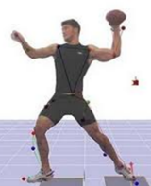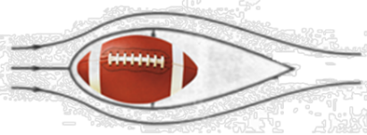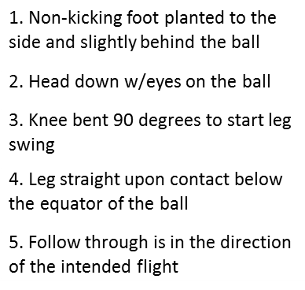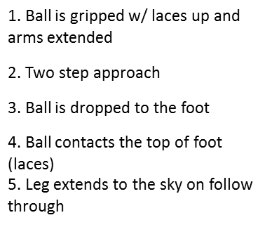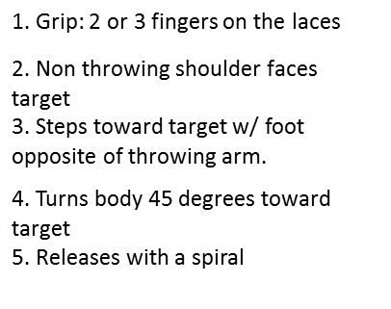**Study Guide: Football Concepts**

**TERMS**

Spiral – a kick or pass in which a football rotates on its long axis while moving through the air

Aerodynamic - - the qualities of an object that affect how easily it is able to

move through the air

Leverage – the increase in force gained by using a lever (arm or leg)

Trajectory – the curved path along which something (such as a football) moves through the air or through space



Equator of the Ball: Middle of the ball that divides it equally into 2 halves

Kicking contact

1. Results in a grounder
2. Results in a line drive
3. Ideal 45 degree flight
4. High pop fly



PASS

PUNT



Stop, Think & Plan

Skill components of Fitness relating to footbal

Balance – control or stabilize your body.

Power – applying maximum force on your muscles

Speed – moving your body parts fast and swiftly

Coordination – using the eyes and ears to determine and direct movement of the body

Agility – changing direction quickly

Reaction Time – respond quickly to what you hear, see or feel

KICK

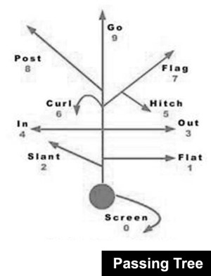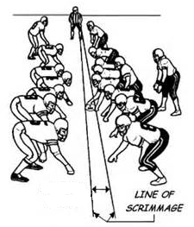

**Line of Scrimage** - An imaginary line running through the ball from sideline to sideline where the ball is downed. The ball cannot be passed forward after it crosses the line of scrimmage.

**Pass Route** – A predetermined route involving a change of direction or speed that a receiver follows to get to open space so the passer can find them and get the ball to them quickly.

**Pass Route** – A predetermined route involving a change of direction or speed that a receiver follows to get to open space so the passer can find them and get the ball to them quickly.