STRENGTH TRAINING STUDY GUIDE

Weight Room Rules
Collars
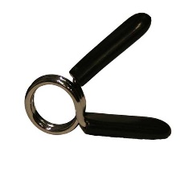
• NO HORSEPLAY (fooling around) AT ANY TIME
• Wear proper lifting clothes & shoes (NO open toe shoes)
• DO NOT slam down the weights
• Use a spotter at free weight lifting stations
• bench press, squat…
• Use collars or clips on the free weight bars
• CLEAN UP (Return equipment to where it belongs)
• DON’T MAX OUT (don’t try to see how much you can lift in one attempt)
• Report an injury immediately
Definitions
Spotter – helps or supports another person during a particular exercise, with an emphasis on allowing the participant to lift or push more than he could normally do safely.
Importance: - Safety
- Psychological Benefit – creates encouragement and a sense of confidence
- Physical Benefit – having supervision encourages a greater training load
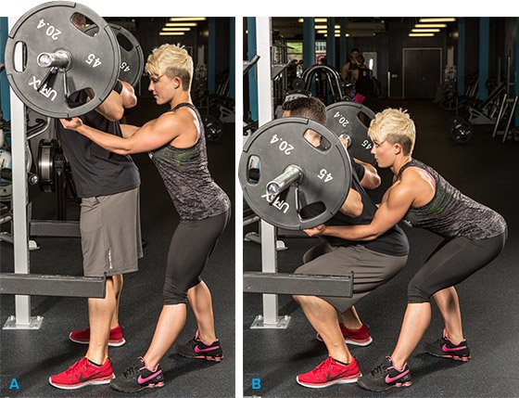
which increases strength
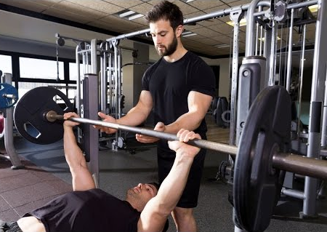

EXERCISE PRINCIPLES
Overload – applying a greater than normal stress or load (weight) on the body to produce increases in strength.
Progression – The gradual increase in the intensity (how hard you work) and time spent on an activity. For example, adding a little more weight than you previously lifted or running a minute longer than what you normally run.
F.I.T.T. Frequency – how often you should be active or the number of days you take part in physical activity in a week. (3 to 6 days per week)
Strength Training Intensities
Light: 10 to 15 reps
Medium: 5 to 9 reps
Heavy: 1-4 reps
Intensity – how hard you exercise
Time – how long you do should do daily physical activities
(30 to 60 minutes)
Type – what kind of activity
1. Cardiovascular
2. Muscular Strength
3. Muscular Endurance
4. Flexibility

Leverage – The exertion of force by means of a lever. Good leverage will allow you to perform a skill with more ease and less effort.
Deadlift
Poor Leverage vs Good Leverage
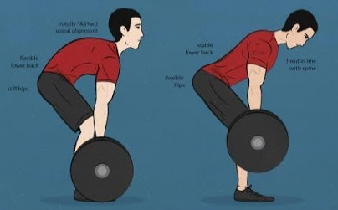

General Strength Training Guidelines
- Breathe: inhale during the relaxation phase (easy part) and exhale when exerting force against the resistance.
Creates stability for the spine
Prevents high blood pressure and the possibility of passing out.
- Lift in a slow and controlled motion
- Keep the resistance close to the midline of your body to decrease the leverage on your spine
- Maintain good posture

