STUDY GUIDE: BASKETBALL / FLOOR HOCKEY

BASKETBALL SKILLS and TERMS
The ball handler should spread their finger pads out on the ball for control when shooting, passing or dribbling.

Triple Threat - A position assumed by the player with the ball that allows them to shoot, pass or dribble. The player should square up to the basket so they can see the best option.

1. Shooting – Look to see if you can score first.
B – balance (weight over feet/ball over hand)
E - eyes on the target
E - elbow under the ball
F - followthrough toward the target.
1. jump shot or form shot: aim for the basket
2. lay-up: aim for the upper corner of the box

2. Passing – If you don’t have a shot then look for a teammate who can.
- Step toward your target
- Follow through so the receiver can catch it in the triple threat position
- The ball should be passed with some speed so it isn’t easily stolen. Lobs passes are easy to steal.
Receiving - Step toward the ball (don’t let your opponent beat you to the ball). Give to absorb the force of the pass

3. Dribble – A way of moving with the ball by bouncing it vertically (up and down). Used to drive toward the basket for a lay-up or toward open space to get open to shoot or pass.

Pivoting – A skill allowing the basketball player with the ball to square up to the basket or dodge the defense without dribbling or walking with the ball. One foot remains fixed to the floor while the other is free to move.

Rebound - a shot ball that bounces back after striking the backboard or rim
Traveling – Holding or carrying the ball when moving. Violation of the rules.
Double Dribble - an illegal dribble that occurs when a basketball player dribbles with both hands simultaneously or stops the dribble by holding the basketball and then restarts the dribble. Violation of the rules.

FLOOR HOCKEY SKILLS and TERMS
Forehand - When a player shoots or passes with the bottom hand pushing the stick forward. Step toward the target with the foot opposite of the lower hand.
Backhand - When a player shoots or passes with the bottom hand pulling the stick backwards. Step toward the target with the same foot as the lower hand

Trapping – Stopping or gaining control of the puck. Hold the stick so the handle is angled to increase the amount of surface area (more of the blade touching the puck) and improve control.

Face Off – A way of starting play. The puck is placed between the sticks of two opposing players.

High Sticking – Anytime the floor hockey stick is raised above the knees (NCMS PE rule). This is a rule to keep the game safe.

Dribble – a way of moving with the puck by pushing it forward (horizontally)

TERMS RELATING TO BASKETBALL & FLOOR HOCKEY
Offense – the team possessing the ball or puck that is attempting to score
Deffense – the team defending or protecting the basket or goal.
B – between (positions themselves between the basket or goal, and the offense)
A – attack (puts pressure on the offense and closes space)
T – take away (attempts to steal the ball or puck)

Give & Go - an offensive play in which a player passes the ball or puck to another teammate, then runs past an opponent, and receives it back immediately from the other player
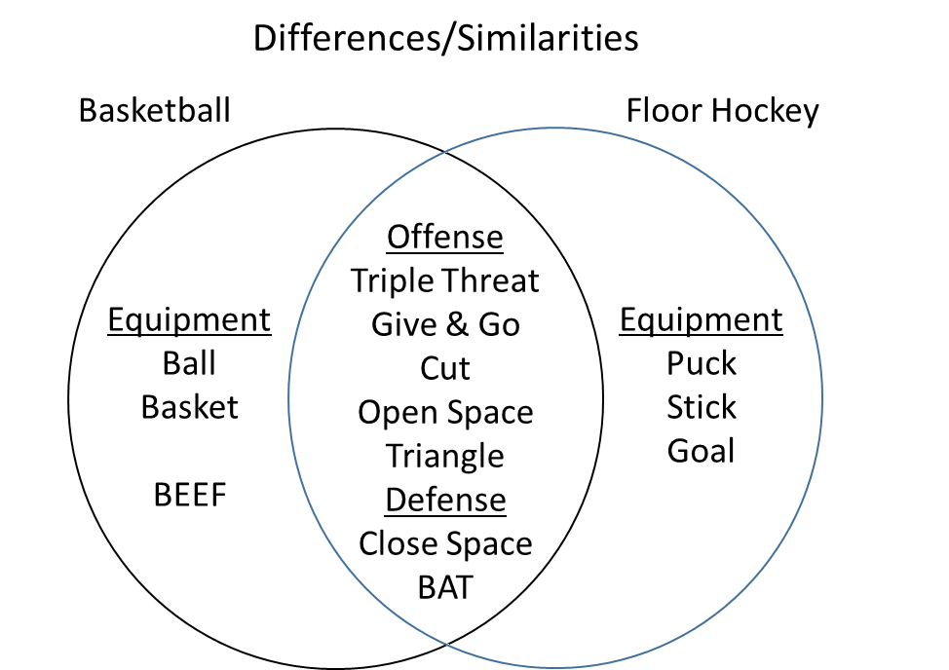
Cut – a sudden movement to get open for
a pass. Changing the speed and direction
of movement increases the success of
getting open

HEART RATE

Resting Heart Rate - A measure of the heart rate following inactivity or rest. The true resting heart rate is when you wake up in the morning before you get out of bed.
Maximum Heart Rate – highest number of beats your heart should beat per minute (220 – your age)
Target Heart Rate – where you want your heart rate to be during exercise (approximately 130 – 180 bpm)

How to Measure Your Pulse or Heart Rate
1) Feel at your neck or wrists with the fingertips of your index and middle fingers for your pulse point until you detect pulsations.

2) Keep yourself as still as possible while you are taking your heart rate. Do not hold your breath.
3) Count the number of heartbeats you feel during one of the time periods on the data chart below and multiply it by the corresponding number to determine the beats per minute.

Time Periods | Multiplier
6 seconds | X 10
10 seconds | X 6
15 seconds | X 4
30 seconds | X 2
1 minute | X 1

